BOARD RECRUITMENT PACK
  - Kent and Medway Active Partnership

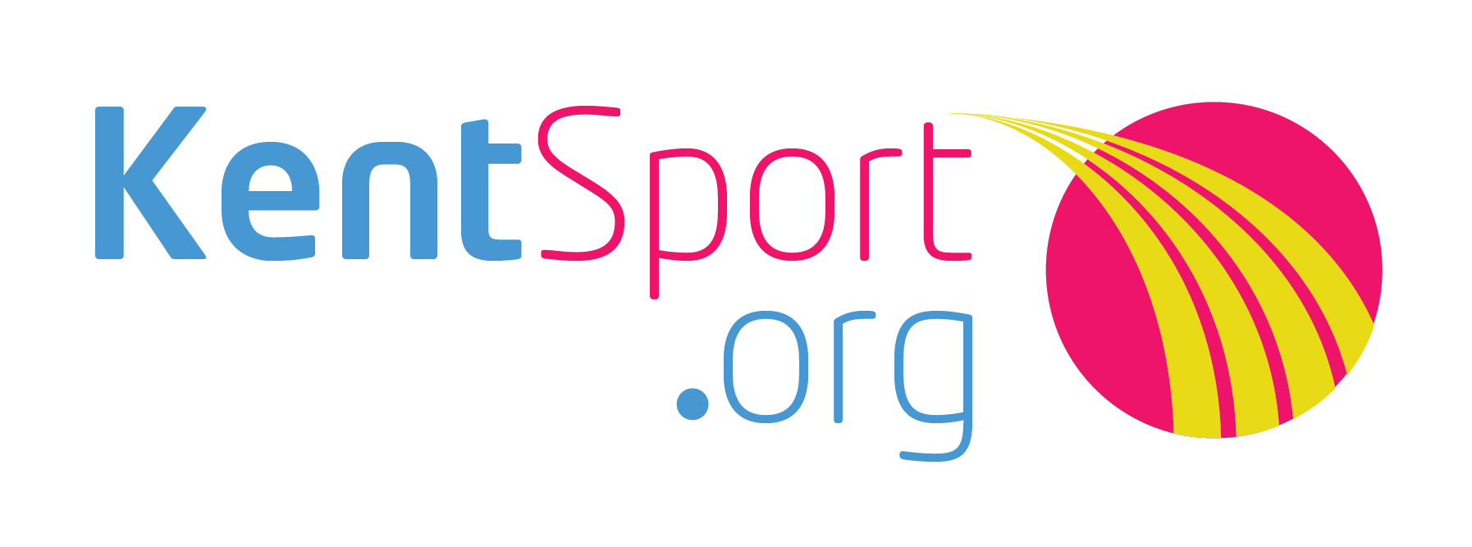

Contents
About the Kent and Medway Active Partnership 3
Welcome Message from the Board Chair 4
Introduction 5
How to apply 5
Contact 5
Accessibility 5
Role Description – Board Member 6
Eligibility 6
Remuneration 6
Location 6
Term 6
Time commitment 6
Main duties of Board Members: 7
Main responsibilities of the Board 7
Experience 8
Skills and Knowledge 8
Further Information 8
Development 8
Selection and appointment 8
KEY DATES 9
Closing date 9
Interview dates 9

About the Kent and Medway Active Partnership
The Kent and Medway Active Partnership is one of 43 Active Partnerships in England and currently operates as Kent Sport.
Our principal funders are Sport England and Kent County Council, whose strategies set the direction of our work and activity.
Kent County Council also hosts the partnership in its offices, providing support services, and is the employer of our staff team.
We also work with and are supported financially by Medway Council and the 12 district and borough councils across the county.
Our vision is ‘more people, more active, more often’.
Our mission is to ‘change and improve lives through sport and physical activity’.
We aim to increase participation in sport and physical activity and promote the benefits of a healthy lifestyle for all our 1.9m residents, especially among under-represented groups, including women, older people, people living with a disability or long term health condition, ethnically diverse communities and people from lower socio-economic groups.
We engage with partners and networks across Kent and Medway – including those in health, adult social care, community safety, housing and transport as well as governing bodies of sport, clubs, school sports networks and local authorities, to provide opportunities for everyone to get involved in sport and physical activity for enjoyment as well as wider health and social outcomes.
Working as partners, we are committed to increasing participation in sport and physical activity across Kent and Medway, adding value by working together, with a focus on encouraging the least active to become more active.
This unincorporated partnership is directed and guided by an independent board which sets the strategy and oversees, scrutinises and guides the work of the staff team, making decisions where appropriate. It is responsible for the provision of good governance and overseeing delivery of the Strategic Framework for Sport and Physical Activity for Kent and Medway.

Welcome Message from the Board Chair
More People, More Active, More Often
This opportunity to join the Board of the Kent and Medway Active Partnership comes at an exciting time.
Sport England has recently published its new ten-year strategy ‘Uniting the Movement’ with its vision to transform lives and communities through sport and physical activity, with a focus on ensuring everyone has equal access to being physically active.
Kent County Council has also re-affirmed its support as the host organisation for our unincorporated partnership.
As Kent County Council’s Kent Sport, we have an excellent team of staff, who work with a wide range partners to promote, support and encourage sport and physical activity opportunities across Kent and Medway.
We have been one of the leading and most successful partnerships in the country for several decades, but a recent review identified an opportunity to work to a different business model going forwards.
We need a Board with broad a range of perspectives, knowledge, experience and insight to improve our governance and help us through the transformation to become a more independent and representative organisation. With a remit to tackle inactivity and encourage people - especially from under-represented groups - into sport and physical activity -we are looking for applicants who can help us to make a difference.
We want to build on our previous achievements and lead more people from all communities and backgrounds becoming more active more often.
If you believe you have the interest, skills, experience, commitment and motivation to meet this challenge then we look forward to receiving your application.
I hope this Recruitment Pack provides the information you need to submit your application. If you would find it helpful to have an informal discussion about this role then please contact me via email to arrange a convenient time.
Dick Fedorcio OBE, Chair
dick@fedorcio.com

Introduction
This is a great opportunity to influence the way sport and physical activity is developed across Kent and Medway. Physical activity can transform lives and reduces the risk of developing serious illnesses, so our vision is to help ‘more people, to be more active, more often’.
The Board is looking to recruit new members with experience in the voluntary, public or commercial sector involved in one or more of the following: community development, children and young people, health, adult social care and active environments.
We are particularly interested in individuals who have the skills and knowledge of working with ethnically diverse communities, disadvantaged or under-represented communities and people living with a disability or long-term health conditions. Prospective Board Members will demonstrate a strong commitment to physical activity coupled with networking and influencing skills, and the ability to think creatively.
To achieve our goals the Board is actively seeking a diverse membership and particularly welcomes applications from anyone who can meet the criteria, regardless of gender, gender identity, race, ethnicity, age, disability, sexual orientation, marital status or religion.

For further information please visit our partnership board webpages.

How to apply
To apply for this role please use our online application form.
Closing date: 5pm on Thursday 19 August 2021

Contact
If you have any questions about this opportunity, please contact:
Louise Milne, Active Partnership Manager
03000 410696 or louise.milne@kent.gov.uk

Accessibility
We make every effort to make our content accessible but if you require this information in an alternative format, please contact our office on 03000 414001 or email kentsport@kent.gov.uk.

Role Description – Board Member

Eligibility
Board Members should, preferably, either live or work within Kent and have an interest in helping people to be active to benefit their health and wellbeing within Kent, (as defined by the Kent County Council and Medway Council area). Experience of having been a Board Member previously is not a requirement and relevant training will be provided as part of the induction process.
The Board is actively seeking a diverse membership and welcome applications from anyone who can meet the criteria, regardless of gender, gender identity, race, ethnicity, age, disability, sexual orientation, marital status, or religion.
Board Members must be aged 18 or over and entitled to live and work in the United Kingdom.

Remuneration
These are non-salaried positions. Travel and other reasonable expenses will be reimbursed.

Location
Board meetings and events will be held either online or at various locations throughout Kent and Medway.

Term
Four years with the opportunity to be considered for reappointment for a second term of four years.

Time commitment
On average, up to 1 day per month and includes:
- An induction training event.
- A minimum of four meetings of the Board annually – generally January, April, July and October.
- Up to two Kent & Medway Active Partnership team (Partnership) events annually.
- Act as Board Champion, Chair, or represent the Board, on time limited working groups or at conferences and launch events, etc.
- Training and development opportunities.

Main duties of Board Members:
- Provide effective leadership and Governance.
- Set the strategic direction of the Partnership.
- Advocate and build relationships with strategic stakeholders for the Partnership.
- Champion a discrete portfolio, thematic area or aspect of the business plan.
- Contribute towards ensuring the Partnership is fit for purpose and continuously improves.
- Support the Partnership’s Chair, Director, and management team.

Main responsibilities of the Board
- Strategy development: Actively and constructively contributing to and challenging development of the Partnership’s strategy and business plans.
- Decision-making: Ensuring that, in reaching a decision, the Board takes into account any relevant guidance issued by regional and national agencies as well as recommendations from Partnership officers.
- Delegated authority: Ensuring that the Board operates within the limits of its delegated authority. Board members do not have any individual delegated authority.
- Financial scrutiny: Ensuring that administrative and other systems of financial control are rigorous and constantly maintained, monitored and developed.
- Risk management: Ensuring that risk management systems are robust and defensible so that major risks are identified and appropriately managed.
- Policy setting and endorsement: Setting policy and ensuring that operational management of the Partnership is carried out in accordance with the policies and procedures of the Partnership and its host agency including those relating to Equalities and Safeguarding.
- Overseeing results: Ensuring the delivery of planned results by monitoring and evaluating performance against agreed strategic objectives and targets.
- Contributing to the work of the Board: Providing effective leadership, contributing to the work of a high performing Board, and being an active team member.
- Supporting the Chair, other Board Members, Director and other management staff.
- Being an advocate for Kent Sport: encourage member agencies to support, and invest in, the Partnership.
- Planning and monitoring: Read and respond to the Partnership’s policies, plans, reports and proposals.
- Code of conduct, duties and personal liability: Abide by the code of conduct for all Board Members.

Experience
The Board is currently looking to recruit several Board members with experience or interest in one or more of the following:
- Community development,
- Children and young people,
- Health and social care (including Clinical Commissioning Groups and/or GPs),
- Active environments,
- The voluntary and community sector (VCS),
- The commercial sector.

Skills and Knowledge
The Board is particularly interested in individuals who have the skills and knowledge of:
- Working with:
    - Ethnically diverse communities,
    - Disadvantaged communities,
    - People living with a disability or long-term health conditions,
- Monitoring and evaluating social and or economic impact,
- Networking and influencing,
- The ability to think creatively.

Further Information
Prior to being formally appointed applicants will need to complete declarations of interests and declarations of good character forms, in order to confirm that they are eligible to be a Board Member.

Development
On successful appointment to the Board, you will be asked to complete a short exercise to identify key skills, knowledge and experience that you have which can support Kent Sport and the Board in its work. We will have a Board member induction session which you will be required to attend and which will support you in your understanding of the Active Partnership’s work and the work of the Board. You will also be asked to participate in an annual Board appraisal exercise and encouraged to make use of appropriate Board Governance development opportunities, such as those provided by the Active Partnerships national network. Other development opportunities for Board Members are also provided through Kent Sport, such as e-learning.

Selection and appointment
Suitable Applicants will be invited for an informal interview with the Chair, other Board Members and the Active Partnership Director.

Appointments will be made subject to receipt of satisfactory references and completion of declaration of interests and declaration of good character forms. References will only be taken up and declarations asked to be completed if an applicant is asked to be Board Member.

All Board members are expected to adhere to the Board Code of Conduct. This will be provided if an applicant is invited to become a Board member.

Key Dates

Closing date
5pm on Thursday 19 August 2021.

Interview dates
Dates to be confirmed but not before 1 September 2021.

