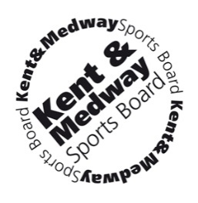

Kent & Medway Sports Board

Changing lives through sport and physical activity…

The Kent & Medway Sports Board independently provides good governance for the work of Kent Sport, the County Sports Partnership (CSP) hosted by Kent County Council. It also oversees the delivery of the Strategic Framework for Sport and Physical Activity for the county provided and co-ordinated by the Kent Sport staff team.

This is an exciting time of transition with new Government and Sport England Strategies focusing on health, well-being and tackling inactivity and providing opportunities for under-represented groups to participate in sport and physical activity. We are currently refreshing our own Strategic Framework to deliver against these agendas.

To complement this change, the Board is being restructured from April 2017 and is looking to recruit new high performing individual members with experience of a range of sectors including commercial, health and social care (including Clinical Commissioning Groups and/or GPs), the voluntary and community sector (VCS) and community development.

We are also particularly interested in individuals who have the skills, experience and knowledge of business development, income generation and working with disadvantaged communities and under-represented groups. Prospective Board Members will demonstrate a strong commitment to sport and physical activity coupled with networking and influencing skills and the ability to think creatively and strategically.

The Kent and Medway Sports Board is actively seeking a diverse membership and particularly welcomes applications from anyone who can meet the criteria, regardless of gender, gender identity, race, age, disability, sexual orientation, marital status or religion.

This is an exciting opportunity to influence the way sport and physical activity is developed across Kent and Medway - delivered through high quality programmes and helping to improve the health and social development of our communities.

For further information about joining the Board please contact Kevin Day, Sport and Physical Activity Manager and CSP Director on 03000 411936 or kevin.day@kent.gov.uk.

Closing date: 12noon on Friday 6 January 2017.

Application forms and details are available via this link: www.kentsport.org/jobs

